高考英语阅读题命题技巧和方法

（以2021年新高考1卷阅读题为例）

**一、概述**

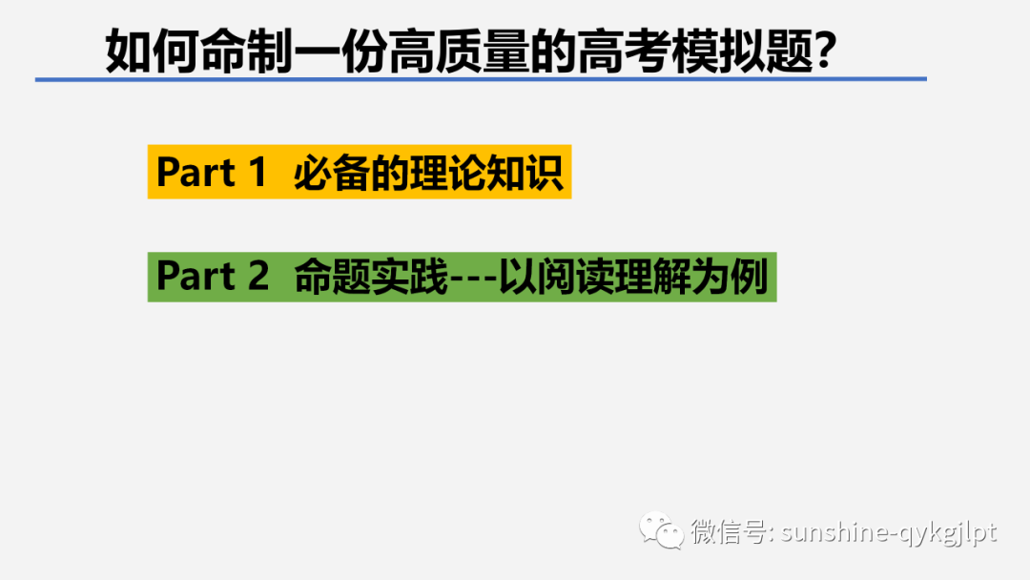

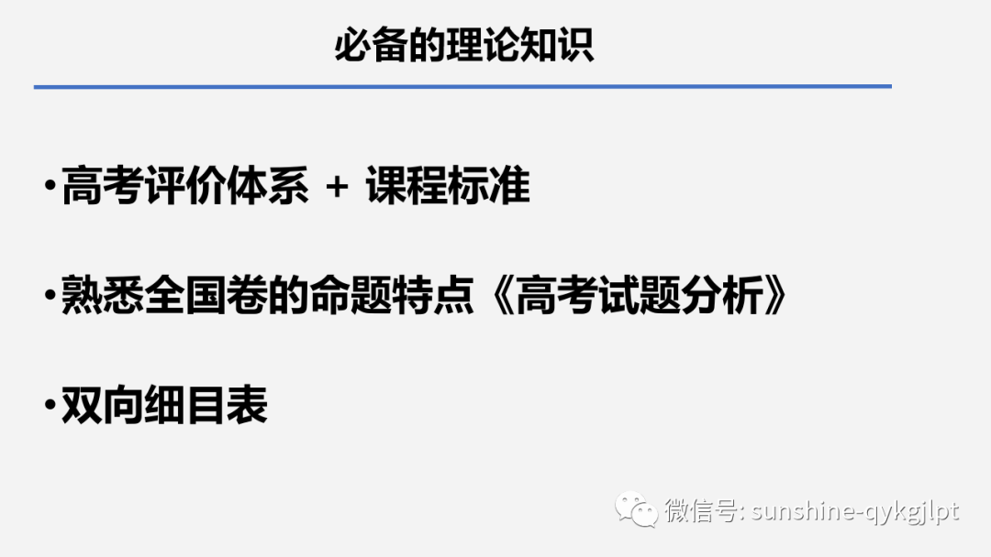

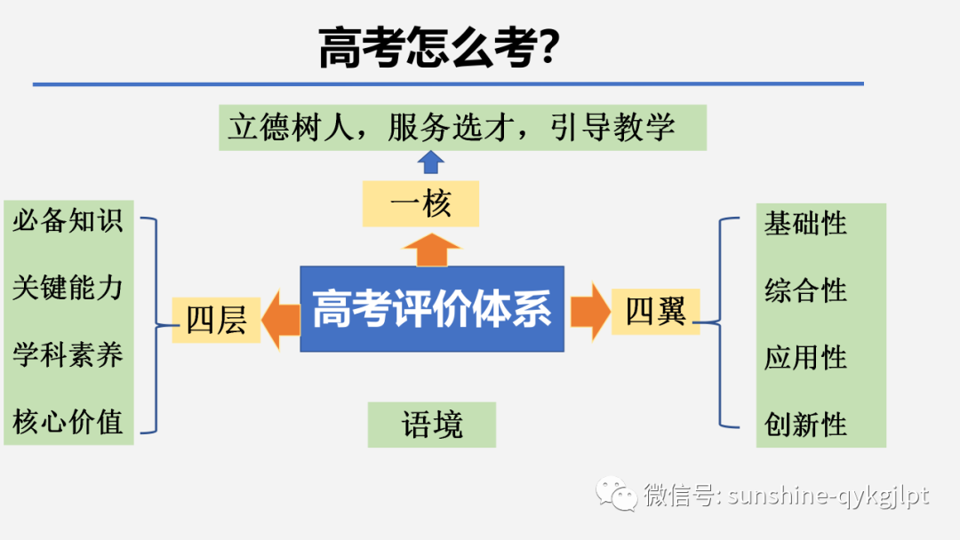

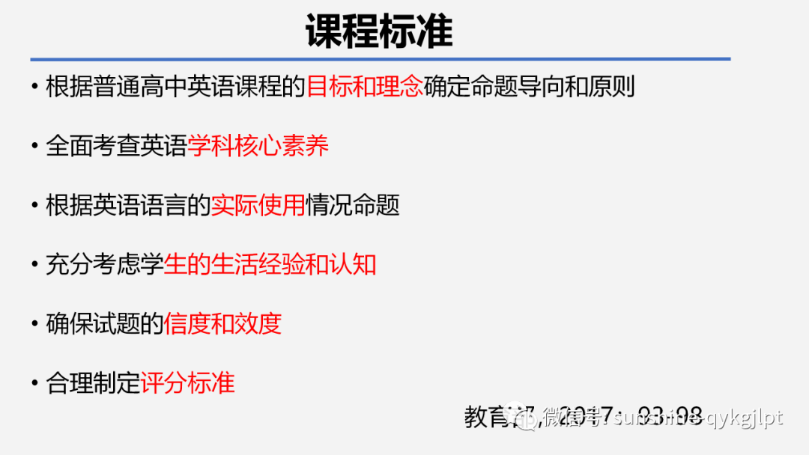

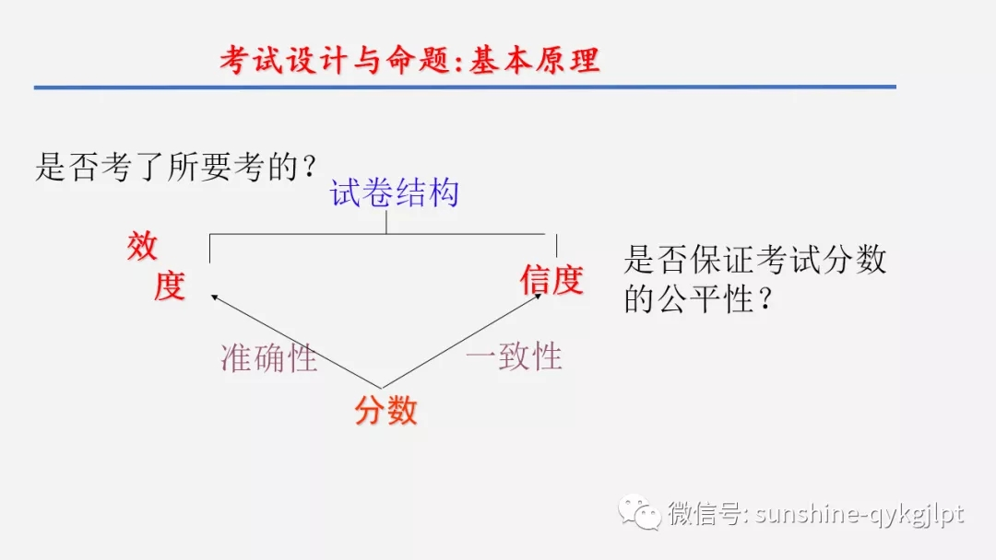

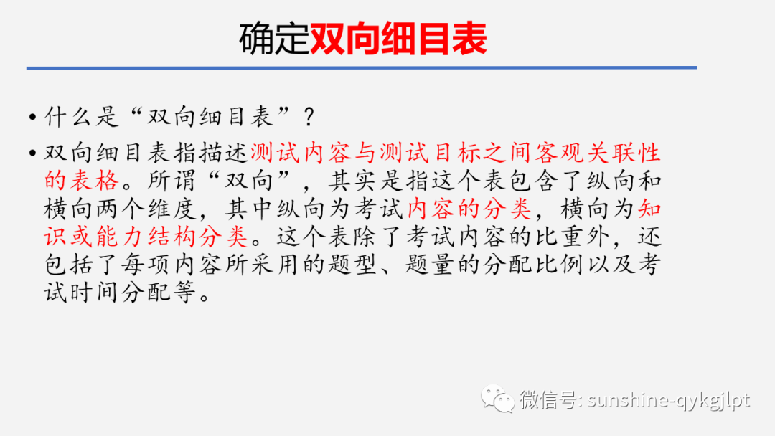

**二、命题实践：以21全国新高考英语阅读为例**

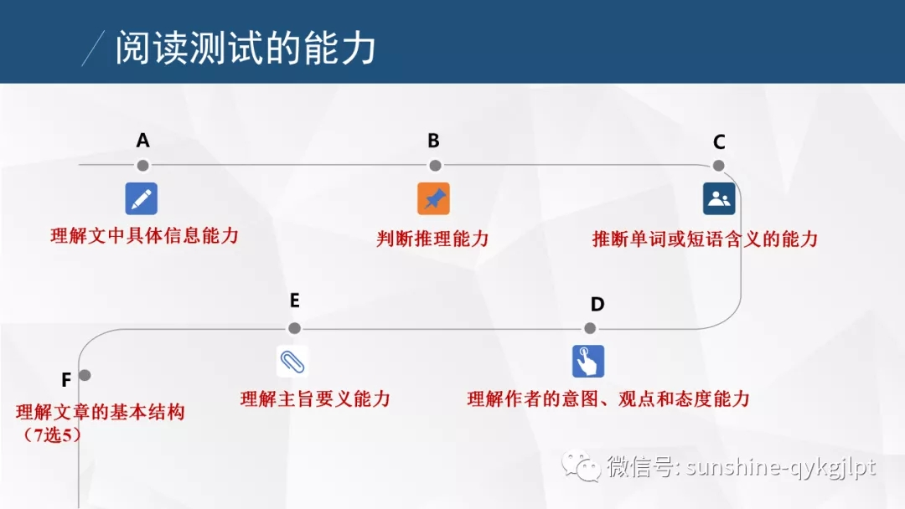

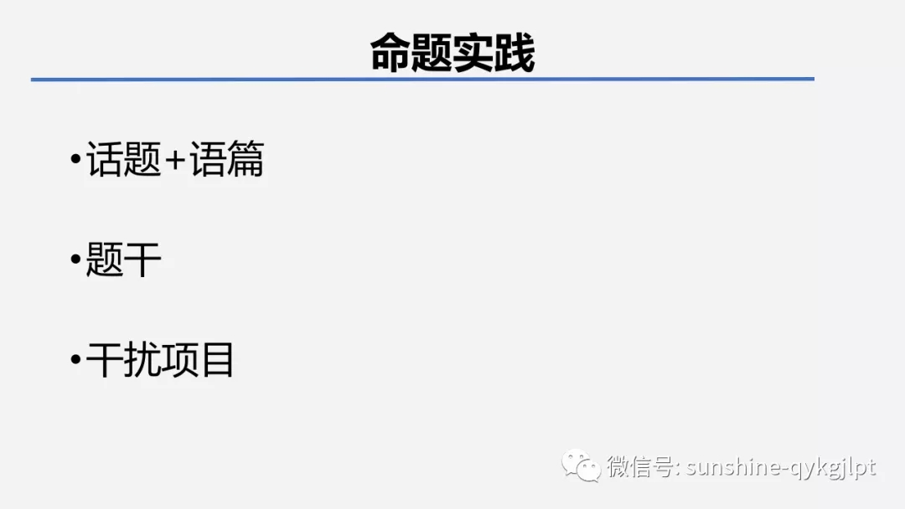

**话题和语篇的选择**

1）阅读材料应该严格按照教材目录的**重点话题**结合**近两年的热点**进行组合，保证学考不分离，不读死书。如今年的艺术与环保组合、网络与课程组合。为完形填空、语法填空，特别是为写作提供语言支撑，保证学生有话可说，有话能说。

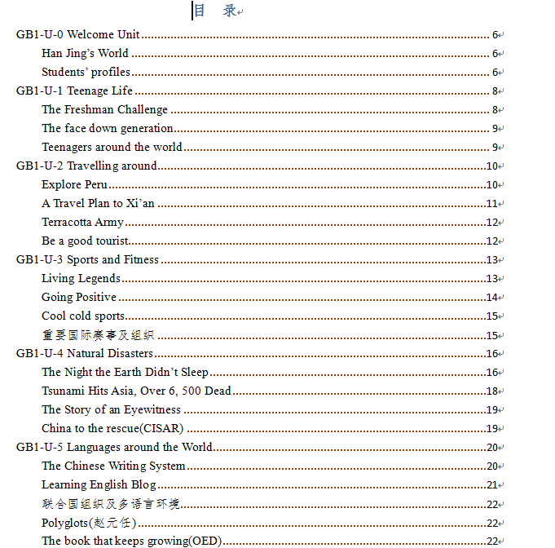

阅读题**题干及干扰项的设置**

**（以**2021年新高考1卷为例**）**

|  |  |  |
| --- | --- | --- |
| **主题** | **知识&能力考查点示例** | **难度** |
| **A**  推荐罗马旅社 | 21. What is probably the major concern of travelers who choose to stay in a hostel?  A. Comfort. B. Security. C. Price. D. Location.  **能力考核：**细节理解题。  **设题根据：**“Rome can be pricey for travelers, which is why many choose to stay in a hostel (旅 社).”  **干扰项设计：提取及概括出关键词。**  **答题陷进：**  **1）**如果把“you’ll often get to stay in a central location”中的get to理解为have got to就会选D。  2）如果把题干中的who choose理解为who have chose也会选D。 | 中 |
| 22. Which hotel best suits people who enjoy an active social life?  A. Yellow Hostel. B. Hostel Alessandro Palace.  C. Youth Station Hostel. D. Hotel and Hostel Des Artistes.  **能力考核：**细节理解。  **设题根据**：“If you love social hostels, this is the best hostel for you in Rome. Hostel Alessandro Palace is fun.”  **干扰项设计：**选取**同类**关键信息  **答题陷进：无**  **设计反思：**考查快速scan能力时，只要把文本中的**同类**关键信息囊括进去就行。 | 易 |
| 23. What is the disadvantage of Hotel and Hostel Des Artistes?  A. It gets noisy at night. B. Its staff is too talkative.  C. It charges for Wi-Fi. D. It’s inconveniently located.  **能力考核：**细节理解。  **设题根据**：“However, you need to pay 2 euros a day for Wi-Fi.”为了确保答案的唯一性，一般转折处是命题的高频点。  **干扰项设计**：张冠李戴，正话反说  **答题陷进：**如果根据“Hotel and Hostel Des Artistes is located just a 10-minute walk from the central city station”过度发挥就会选A。因为靠近车站通常会很吵。  **设计反思：**这里的干扰项采用了“过度发挥”，“正话反说”两个手段。制作干扰项时，应该尽量在出题点附近找点，不够再在文本中的其他部分找。实在不够才能“无中生有”，否则没有干扰性。 | 中 |
| **B**  我的演出好搭档：乐手与翻歌谱的人 | 4. What should Titterton be able to do to be a page turner?  A. Read music. B. Play the piano.  C. Sing songs. D. Fix the instruments.  **能力考核：**细节理解。  **设题根据：“**I’m not a trained musician, but I’ve learnt to read music so I can help Maria in her performance.**”**  **干扰项设计：正话反说，无中生有**  2**答题陷进：** 无 | 易 |
| **能力考核：**简单的推理判断。  **设题根据：“**He said he became just as nervous as those playing instruments on stage.**”, “**A lot of skills are needed for the job.” “Being a page turner requires plenty of practice.”  **干扰项设计**：A为曲解原意，BD为无中生有。  25. Which of the following best describes Titterton’s job on stage?  A. Boring. B. Well-paid.  C. Demanding. D. Dangerous.  **答题陷进：** 无  **设计反思：**因为是细节综合推理，为了降低难度采用了有两个“无中生有”项。 | 中 |
| 26. What does Titterton need to practise?  A. Counting the pages. B. Recognizing the “nodding”.  C. Catching falling objects. D. Performing in his own style.  **能力考核：**细节理解。  **设题根据**：“Silent onstage communication is key, and each pianist has their own style of “nodding” to indicate a page turn which they need to practise with their page turner.”  **干扰项设计**：A为词义辨析，C为断章取义，D为无中生有  **答题陷进：**如果把counting理解为turning就会答错。 | 易 |
| 27. Why is Ms Raspopova’s husband “the worse page turner”?  A. He has very poor eyesight. B. He ignores the audience.  C. He has no interest in music. D. He forgets to do his job.  **能力考核：**细节理解  **设题根据**：“He’s interested in the music, feeling every note, and I have to say: ‘Turn, turn!’”  **干扰项设计**：AB为无中生有，C正话反说  **答题陷进**：无  **设计反思**：因为是细节概括题，为了降低难度采用了有两个“无中生有”项。 | 中 |
| **C**  美国的鸭子邮票史 | 28. What was a cause of the waterfowl population decline in North America?  A. Loss of wetlands. B. Popularity of water sports.  C. Pollution of rivers. D. Arrival of other wild animals.  **能力考核：**细节理解  **设题根据**：“Millions of acres of wetlands were dried to feed and house the ever-increasing populations, greatly reducing waterfowl habitat (栖息地).”  **干扰项设计**：C为无中生有，BD偷换了核心概念。  **答题陷进**：无  **设计反思**：题干中的a用得特好。在有多个可选项时，题干这样设可以避免Which of the following is这样的累赘表达。 | 易 |
| 29. What does the underlined word “decimate” mean in the first paragraph?  A. Acquire. B. Export. C. Destroy. D. Distribute.  **能力考核：**词义猜测  **设题根据**：利用“Millions of waterfowl ( 水 禽 ) were killed at the hands of market hunters and a handful of overly ambitious sportsmen.”中的同义词kill-destroy复现。  **干扰项设计**：无  **答题陷进**：无  **设计反思**：所谓的猜测，画线词附近必须要有适当的细节来支持。 | 中 |
| 30. What is a direct result of the Act passed in 1934?  A. The stamp price has gone down.  B. The migratory birds have flown away.  C. The hunters have stopped hunting.  D. The government has collected money.  **能力考核：**细节综合  **设题根据**：“Under this Act, all waterfowl hunters 16 years of age and over must annually purchase and carry a Federal Duck Stamp.” 及“About 98 cents of every duck stamp dollar goes directly into the Migratory Bird Conservation Fund to purchase wetlands and wildlife habitat for inclusion into the National Wildlife Refuge System…”  **干扰项设计**： A根据原文是正话反说，在这里和B一样是无中生有。C是是正话反。  **答题陷进**：无  **设计反思**：正确选项转弯太突然，Fund未必是government. | 易 |
| 31. Which of the following is a suitable title for the text?  A. The Federal Duck Stamp Story.  B. The National Wildlife Refuge System.  C. The Benefits of Saving Waterfowl.  D. The History of Migratory Bird Hunting.  **能力考核：**标题判断  **设题根据**：时间顺序(timeline)，关键词Duck Stamp  **干扰项设计**：以偏概全为主  **答题陷进**：无  **设计反思**：  1）Story最好改为History。  2）首尾段落对大意的提示不明显，也没主题句。这种娓娓道来的文章概括起来较难。 | 难 |
| **D**  情商研究 | 32. What is a common misunderstanding of emotional intelligence?  A. It can be measured by an IQ test.  B. It helps to exercise a person’s mind.  C. It includes a set of emotional skills.  D. It refers to a person’s positive qualities.  **能力考核：**标题判断细节理解 推理判断  **设题根据**：“Many people now misunderstand emotional intelligence as almost everything desirable in a person’s makeup that cannot be measured by an IQ test,”及“Being emotionally intelligent does not necessarily make one a moral person.”  **干扰项设计**：AC为正话反说；B为张冠李戴  **答题陷进**：用否定法设计题干增加了干扰。  **设计反思**： | 中 |
| 33. Why does the author mention “doctor” and “cheater” in paragraph 2?  A. To explain a rule. B. To clarify a concept.  C. To present a fact. D. To make a prediction.  **能力考核：论点与**论证之间的关系  **设题根据**： “We prefer to describe emotional intelligence as a specific set of skills that can be used for either good or bad purposes. The ability to accurately understand how others are feeling may be used by a doctor to find how best to help her patients, while a cheater might use it to control potential victims.”  **干扰项设计**：概念的辨析  **答题陷进**：宏观理解  **设计反思**： | 中 |
| 34.What is the author’s attitude to the popularization of emotional intelligence?  A. Favorable. B. Intolerant. C. Doubtful. D. Unclear.  **能力考核：**判断作者的态度  **设题根据**：Although popular beliefs regarding emotional intelligence run far ahead of what research can reasonably support, the overall effects of the publicity have been more beneficial than harmful.  **干扰项设计**：  **答题陷进**：1）长句的理解。 2）多个让步从句会混淆作者的重点,如“Although the continuing popular appeal of emotional intelligence is desirable, we hope that such attention will excite a greater interest in the scientific and scholarly study of emotion.”  **设计反思**：意思转弯处经常是命题点。 | 中 |
| 35. What does the last paragraph mainly talk about concerning emotional intelligence?  A. Its appeal to the public.  B. Expectations for future studies.  C. Its practical application.  D. Scientists with new perspectives.  **能力考核：**概括段落大意  **设题根据**：“It is our hope that in coming decades, advances in science will offer new perspectives (视角) from which to study how people manage their lives. Emotional intelligence, with its focus on both head and heart, may serve to point us in the right direction.”  **干扰项设计**：A为张冠李戴 ，CD断章取义  **答题陷进**：  **设计反思**：1）题干尽管有点啰嗦，但可以使得选项更准确，简短。 | 中 |